International Financial Analysis of Australia

Rebecca Wordinger
FIN 480
12:45pm
April 24, 2014

Financial and Economic History
The economy of Australia is one of the largest capitalist economies in the world with a Gross Domestic Product (GDP) of US$1.5 trillion as of 2013 (Central Intelligence Agency, 2014). The economy has experienced more than 20 years of continued economic growth, averaging 3.5% a year, and features low unemployment, contained inflation, very low public debt, and a strong and stable financial system (Central Intelligence Agency, 2014). The Australian dollar is the currency of the Commonwealth of Australia and its territories which include: Christmas Island, Cocos (Keeling) Islands, and Norfolk Island. It is also the official currency of the independent Pacific Island nations of Kiribati, Nauru and Tuvalu.
The Australian economy has had to tackle its share of problems in recent history. Black Monday, when the Dow Jones Industrial Average lost almost 22% in a single day and signaled a global stock market decline, resulted in a recession due to Australia’s close ties to the United States. The recession lasted from the September quarter of 1990 until the September quarter of 1991, during which the country’s GDP fell by 1.7% and unemployment rose to 10.8% (The Age Company Ltd., 2006).
Recent increased demand in resources and energy from Asia and especially China has benefited the country because it is a large commodity producer, creating a channel for resources investments and growth in commodity exports (Central Intelligence Agency, 2014). The country's terms of trade jumped by 30% from 2004 to 2007 to their highest level for over 50 years (The Economist, 2007). Australia has benefited from a dramatic surge in its terms of trade in recent years, stemming from rising global commodity prices. The service sector is the largest part of the Australian economy, accounting for about 70% of GDP and 75% of jobs.
Australia is a significant exporter of natural resources, energy, and food. Their abundant and diverse natural resources attract high levels of foreign investment and include extensive reserves of coal, iron, copper, gold, natural gas, uranium, and renewable energy sources. A series of major investments, such as the US$40 billion Gorgon Liquid Natural Gas project, will significantly expand the resources sector (Central Intelligence Agency, 2014).
The mining industry proved to be lucrative as opportunities for large profits in pastoralism and mining attracted considerable amounts of British capital in the post-war era. As the economy expanded, large-scale immigration became necessary to satisfy the growing demand for workers, especially after the end of convict transportation to the eastern mainland in 1840. Australia's mining operations secured continued economic growth and Western Australia itself has benefited strongly from mining iron-ore and gold from the 1960s and 1970s which fueled the rise of suburbanization and consumerism in Perth, the capital and most populous city of WA as well as other regional centers. Australia's economy grew at an average annual rate of 3.6% for over 15 years, well above the OECD average of 2.5% (The Economist, 2007).
Australia is an open market with minimal restrictions on imports of goods and services which has increased productivity, stimulated growth, and made the economy more flexible. The country plays an active role in the World Trade Organization, APEC, the G20, and other trade forums. Australia has bilateral free trade agreements (FTAs), which facilitate trade and investment between themselves and the following countries by reducing or eliminating tariffs, import quotas, export restraints and other trade barriers with Chile, Malaysia, New Zealand, Singapore, Thailand, and the US (Investopedia, 2014). They also have a regional FTA with the Association of Southeast Asian Nations, or ASEAN and New Zealand. They are negotiating agreements with China, India, Indonesia, Japan, and the Republic of Korea, as well as with its Pacific neighbors and the Gulf Cooperation Council countries. Australia is also working on the Trans-Pacific Partnership Agreement with Brunei Darussalam, Canada, Chile, Malaysia, Mexico, New Zealand, Peru, Singapore, the US, and Vietnam (Central Intelligence Agency, 2014). As of 2012 Australia’s top five two-way trading partners included: China, Japan, United States, Republic of Korea, and Singapore (Australian Government Department of Foreign Affairs and Trade, 2012).

Figure 1: Australi's Trading with the World (Australian Government Department of Foreign Affairs and Trade, 2012)
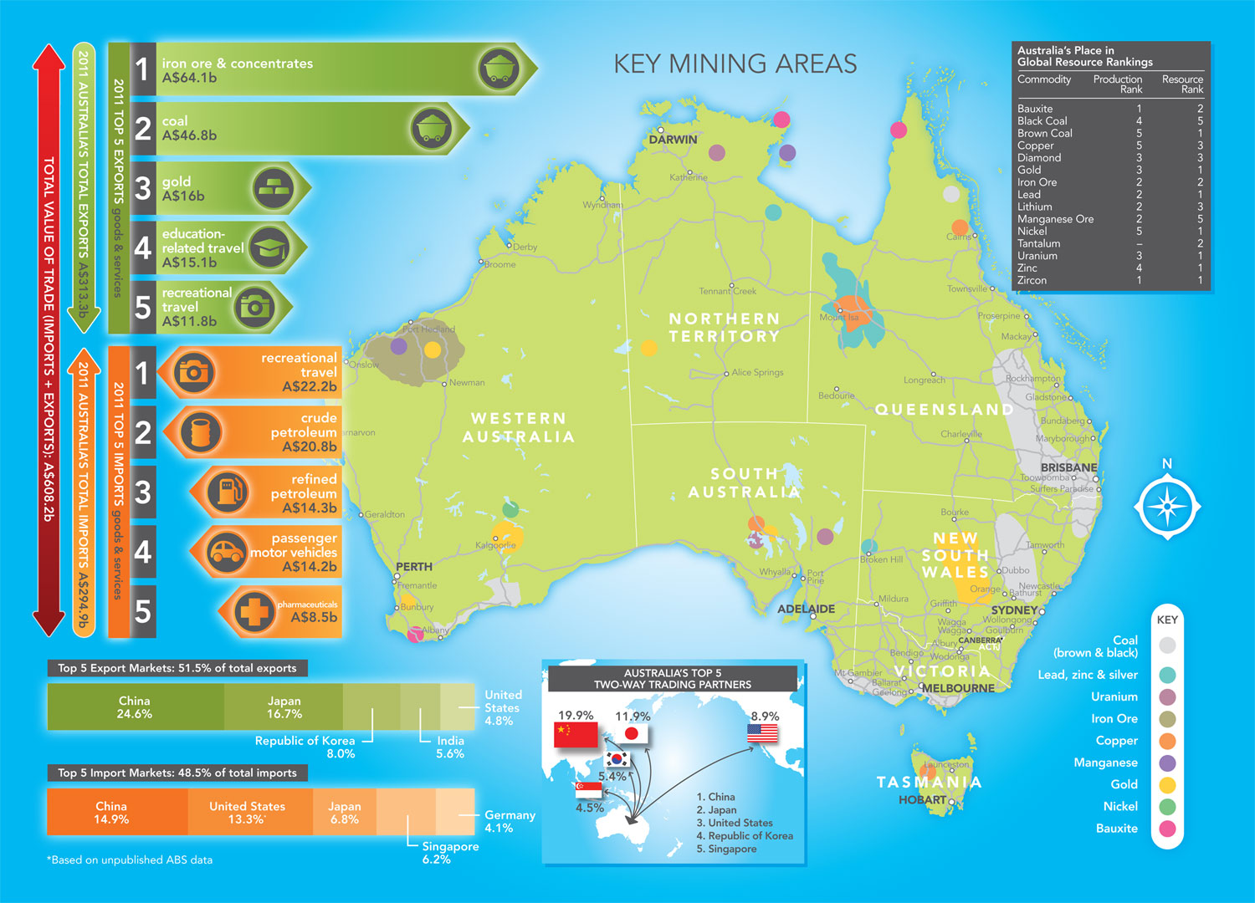

The Balance of Payments
The balance of payments provides a statistical statement that delivers a systematic summary of economic transactions of an economy with the rest of the world, for a specific time period. A transaction is defined as an economic flow that reflects the creation, transformation, exchange, transfer, or extinction of economic value and involves changes in ownership, of goods or assets, the provision of services, labor or capital (OECD). A review of the current account over the last five years reveals a consistent trade deficit, where the monetary value of its imports has exceeded the value of its exports to the rest of the world (see Table 1). The current account is affected by changes in economic growth rates and national income, changes in relative prices or inflation rates, changes in domestic preferences. These deficits indicate that Australia is spending more on foreign trade than it is earning, and that it is borrowing capital from foreign sources to make up the deficit. Therefore, they require more foreign currency than they receive through sales of exports, and they supply more of their own currency than foreigners demand for its products. The excess demand for foreign currency lowers their exchange rate until their goods and services are cheap enough for foreigners, and foreign assets are too expensive to generate sales for domestic interests (Heakal, 2013). The current account deficit slowed in growth in 2010-11 due to the goods and services surplus of $20.8 billion but rose again in 2011-12.
Table 1: Balance of Payments, Current Account Deficit (OECD) 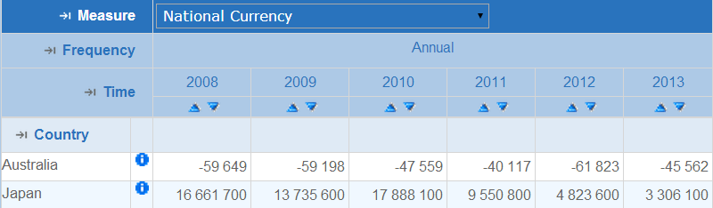

Exchange Rate Trends

The AUD/USD exchange rate took the biggest dive in 2010 when it fell from 1.28 to 1.09. The depreciation of the Australian dollar occurred again the following year in 2011. Increases have been consistent ever since. Economic data from December 2013 as well more recent data have showed improvement. Some reports are even exceeding many analysts’ predictions. As economic indicators in both countries, including unemployment rates, continue to improve the exchange rate will rate will minimally change.
Australian Dollar Exchange Rate (AUD)
Year | AUD/USD | AUD/JPY | AUD/CNY
2008 | 1.20
2009 | 1.28 | 0.0132 | 0.1876
2010 | 1.09 | 0.0124 | 0.1634
2011 | 0.97 | 0.0122 | 0.1527
2012 | 0.97 | 0.0124 | 0.1496
2013 | 1.03 | 0.0105 | 0.1542
2014 | 1.08 | 0.0111 | 0.1881

Parity Conditions

Each month, the Organization for Economic Co-operation and Development (OECD) measures the difference in price levels between its member countries by calculating the ratios of purchasing power parity (PPPs) for private final consumption expenditure to exchange rates. The OECD table indicates the number of US dollars needed, as of February 2014, in each of the countries listed to buy the same basket of consumer goods and services that would cost 100 USD in the United States. On this list Australia is only fourth from the bottom, ranking it as an expensive country in terms of PPP. According to the table, an American living or travelling in Australia on an income denominated in US dollars would find that their money does not go as far as they may like it to, having to spend 40% more US dollars to maintain a standard of living comparable to the USA in terms of consumption (see Table 2).
Table 2: Comparative Price Levels (OECD, 2014)
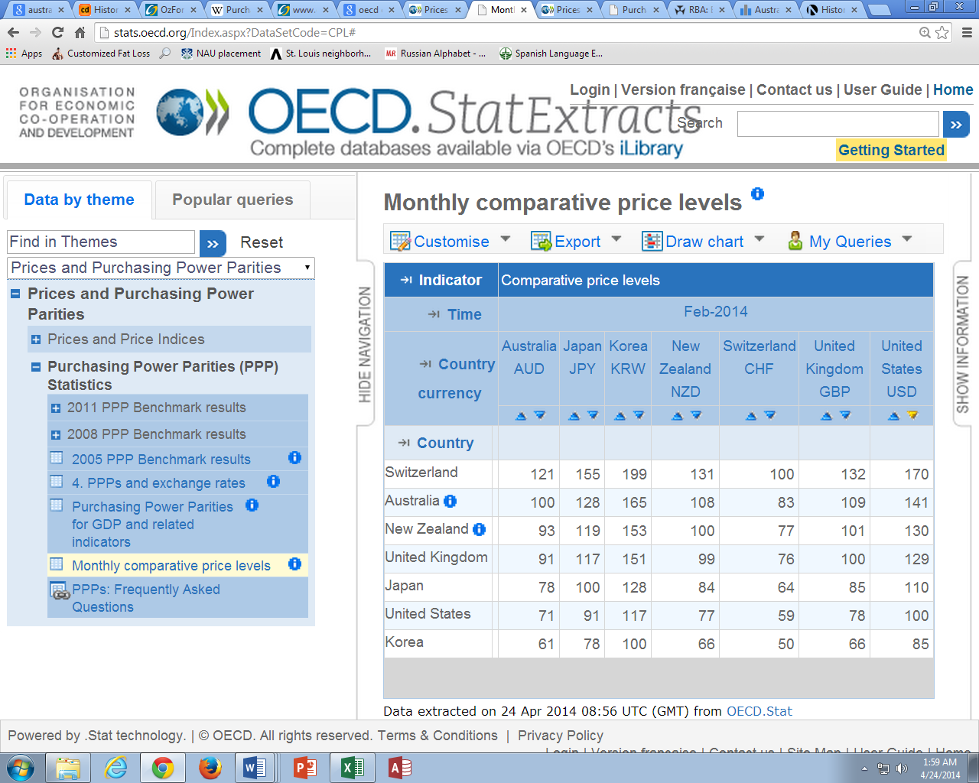

Prediction

I calculated my prediction for Australia’s exchange rate, against the US dollar, as a forward rate for January 2015. This calculation utilized the current average interest rate for both the US and Australia as well as Australia’s current exchange rate. Given this data I predict an exchange rate of AUD1.07/USD (see Appendix A for calculation). Reports state that there is an expected increase in interest rates in the US and improving numbers in both economies with a neutral outlook for the short term and a more positive outlook long term (OzForex, 2014). Therefore I feel that my prediction maintains the sentiments of a neutral change.

Bibliography

Australian Government Department of Foreign Affairs and Trade. (2012). Australia's trade with the world graph. Retrieved April 20, 2014, from Australian Government Department of Foreign Affairs and Trade: http://www.dfat.gov.au/tradematters/aus-graph.html
Central Intelligence Agency. (2014, April 15). The World Factbook: Australia. Retrieved April 2014, from Central Intelligence Agency: https://www.cia.gov/library/publications/the-world-factbook/geos/as.html
Heakal, R. (2013, June 14). Exploring The Current Account In The Balance Of Payments. Retrieved April 20, 2014, from Investopedia: http://www.investopedia.com/articles/03/061803.asp
Investopedia. (2014). Bilateral Trade. Retrieved April 17, 2014, from Investopedia: http://www.investopedia.com/terms/b/bilateral-trade.asp
Investopedia. (2014). Black Monday. Retrieved April 17, 2014, from http://www.investopedia.com/terms/b/blackmonday.asp
OECD. (2014, February). Monthly comparative price levels. Retrieved April 22, 2014, from OECD.StatExtracts: http://stats.oecd.org/Index.aspx?DataSetCode=CPL#
OECD. (n.d.). OECD. StatExtracts Balance of Payments(MEI). Retrieved April 15, 2014, from Organisation For Economic Co-operation and Development: http://stats.oecd.org/Index.aspx?DataSetCode=MEI_BOP#
OzForex. (2014). AUD/USD in Focus Fundamental Outlook. Retrieved April 19, 2014, from ozforex.com: http://www.ozforex.com.au/news-commentary/monthly-focus/January-2014/aud-usd
The Age Company Ltd. (2006, December 6). The real reasons why it was the 1990s recession we had to have. Retrieved April 15, 2014, from theage.com: http://www.theage.com.au/news/business/the-real-reasons-why-it-was-the-1990s-recession-we-had-to-have/2006/12/01/1164777791623.html?page=3
The Economist. (2007, March 29). The Australian economy downwonder. Retrieved April 15, 2014, from The Economist: http://www.economist.com/node/8931798?story_id=8931798
Trading Economics. (2014, April 22). Australia economic indicators. Retrieved April 22, 2014, from Trading Economics: http://www.tradingeconomics.com/australia/indicators

Appendix

Appendix A
Exchange rate calculation for January 2015
Current Spot Rate |  | A$1.08/US$
Latest Interest rate* | AUS: | 0.0529 | US: | 0.0608
1/2015 = 8 months |  | =8*30
8 month forward rate
=1.08*((1+(C3*(C4/360)))/(1+(E3*(C4/360)))) | = | 1.07453357
* interest rates source: (Trading Economics, 2014)

