The National September 11th Memorial

By: Taylor Hunt & Becky Wordinger
4/1/2014

Purpose
The National September 11 Memorial, located at the site of the original World Trade Center (WTC) buildings, was built with the purpose of protecting the sanctity of the twin towers and the people affected by the terrorist events of February 26, 1993 and September 11, 2001 (National September 11 Memorial & Museum). These terrorist attacks resulted in the largest loss of life from a foreign attack on American soil and the greatest single loss of rescue personnel in American history (National September 11 Memorial & Museum). The Memorial commemorates the men, women, and children who lost their lives from the attack on the Pentagon, the World Trade Center, all flight members, rescue crews, as well as those killed in the bombing of the World Trade Center in 1993; totaling nearly 3,000 people. The design features two large waterfalls, centered on the locations of the destroyed twin towers. Each space is nearly an acre in size and feature the largest manmade waterfalls in North America with the names of the victims displayed around the perimeter of both (National September 11 Memorial & Museum). The project was an ongoing process following the recovery operation which ended May 30, 2002. It was completed, and the Memorial was dedicated, on the ten year anniversary of the attack, September 11, 2011 (World Trade Center).

Project Details
Following the 9/11 attacks the then-Governor Pataki and then-Mayor Giuliani created the Lower Manhattan Development Corporation (LMDC) to help plan and coordinate the rebuilding and revitalization of Lower Manhattan (Lower Manhattan Development Corporation). The LMDC began holding design competitions for the WTC reconstruction in 2002. On April 28, 2003 they announced the start of the international competition to design the memorial site (Lower Manhattan Development Corporation). More than 5,200 entries were submitted from 63 nations and judged by a 13 member jury (National September 11 Memorial & Museum). Almost a year later, on January 6, 2004, the winner was announced to be Michael Arad’s with his design titled Reflecting Absence (Hagen). Even though the designs were finalized by the end of the same year two years later debris was still in need of being removed from the site. Debris began to be removed on March 13, 2006 signaling the official start of construction (World Trade Center). In 2006 the budget was getting out of control and the design for the memorial was changed. After the design was finalized the footings for the memorial were poured in September 2006. (World Trade Center). Construction continued until September 2011. This project was a fiasco in the beginning due to several logistic and financial issues; however, in the end it was a large success.

Diamond Framework (see Figure 1)
Although this project did not offer a product in the everyday sense of the word the Memorial offered a place where people from around the world could go to remember, mourn, and heal. The memorial site is now the location of the largest manmade waterfalls in North America. As impressive as this undertaking was it was not novel. Adapting the waterfall to the size needed for the project only required extensions and improvements to the preexisting understanding of waterfalls and therefore falls under the category of a derivative.
Technology was not a major issue due to the nature of the project consisting of debris removal and construction. Therefore this project can be classified as a low-tech project. The fountains utilized existing and well-established technologies that simply had to be adapted to the size of the original tower voids.
A review of the system scope reveals that the complexity of the project operated as a system. It involved a complex collection of construction projects jointly occupying the WTC site, resulting in project delays. Another level of complexity arose from the stakeholders influencing the design. This included local and state politicians, family members of the victims, a multi-headed client framework, outside design critics, and the general public (American Society of Landscape Architects, 2012).
The emotional impact of the terrorist attacks on both the families of the victims as well as on the nation as a whole were profound. This impact called for a place in which people could gather and process these feelings. The need for a memorial was felt immediately which prompted officials to establish an interim memorial to be resurrected in 2002 (Lower Manhattan Development Corporation). The urgency of this project can therefore be categorized as fast-competitive as it fulfilled a market need.

Efficiency
Budget
The initial costs for the Memorial were estimated to be $350 million (Hagen). This figure quickly began to change and became a major area of concern with estimates said to have reached $1 billion. The project also encountered numerous construction delays which only added to the cost estimates. These delays were minimally anticipated even though numerous construction projects were occurring simultaneously in the same area. These projects included the Transportation Hub, the Freedom Tower, the WTC 7 building, the Memorial Museum, the Memorial, as well as others. The overall cost for the project was $700 million*. While this is largely over the initial $350 million it is acceptable in comparison to the once anticipated $1 billion. The high cost can be partially attributed to a 30% increase in construction material costs over the building timeframe (Hagen). (*Final costs referenced include the museum with the memorial).

Schedule
The project struggled to stay on track due to the amount of work being done at one location. In 2006 to try to reduce costs Arad’s design was altered by removing the underground memorial galleries. This would bring the names of the victims up to ground level and diminish the ramps leading below the waterfalls. Mr. Arad was furious and spent 6 months fighting this change. After the removal of the ramps was finalized another problem arose. Mr. Arad wanted to place the names of the victims in what he called “meaningful adjacency” so that families could make suggestions as to who their loved ones’ name would be placed next to. Nobody else agreed with this plan. This pushed back the project for 2 years while an agreement was trying to be reached. Once everyone agreed to go with “meaningful adjacency” it took one year to organize all of the names and then construction resumed (Loos, 2011). Work continued for a year until more scheduling problems arose. A three-month long hearing was held to try and solidify a schedule. The arbitration panel ruled to give the Port Authority of New York and New Jersey, and Silverstein Properties 45 days to come up with a new development schedule. The new planning which ended up taking an additional 120 days allowed teams to move forward on select projects, including the Memorial project (World Trade Center). Construction continued until the completion of the memorial within the deadline of 2011.

Impact on Customer
The WTC site has had a large impact on the customer. At first the memorial was viewed negatively by the press because it was taking so long to complete. Plus the issues with the budget led to a negative perception of the memorial. However, that got turned around when the project was completed on time and it impacted. Americans have felt a great sense of pride in the resilience of New York City which is symbolized in the World Trade Center memorial.

Impact on Team
Teamwork lacked during the building of the WTC site. Michael Arad felt that he needed to justify his design when costs started to soar out of control and was defensive against everyone’s ideas. There are many instances where it was reported that he had screaming matches with people. State, local and federal officials were involved, as well as the Port Authority of New York and New Jersey, the developer Larry Silverstein and the state-city Lower Manhattan Development Corporation. There were too many people and organizations with conflicting interests involved for things to move smoothly (Loos, 2011).

Business and Direct Success
The success can be seen in how the project contributed to the organization’s success and effectiveness. Since opening the memorial has welcomed more than 12 million visitors from across the United States and 175 nations (The National September 11 Memorial & Museum). The project also received an award in 2012 from the American Society of Landscape Architects as well as in 2013 from the American Institute of Architects for Regional and Urban Design (American Society of Landscape Architects, 2012) (The American Institute of Architects, 2013).

Preparation for Future
This category of success doesn’t really apply to the WTC site. There was no new technology used in this build and it doesn’t really help the parent organization prepare for the future. The biggest way this development impacts the future is by helping future generations to remember and honor the many people that lost their lives due to this tragedy.

Fiasco to Success
Due to the struggles in the beginning of the project many would deem it as being a fiasco. The budget went higher than expected and the schedule was threatened. However, the project was pulled together and dedicated on the 10 year anniversary of the terrorist attacks. The project has also been very successful since it has opened. It has had more than 12 million visitors from all over the world. It is also an award winning memorial. Most of all it should be considered a success because the memorial has had a great impact on American’s and brought comfort to many that lost loved ones. It has reached its purpose by protecting the sanctity of the twin towers and the people affected by the terrorist events.

Figure 1 Diamond Framework
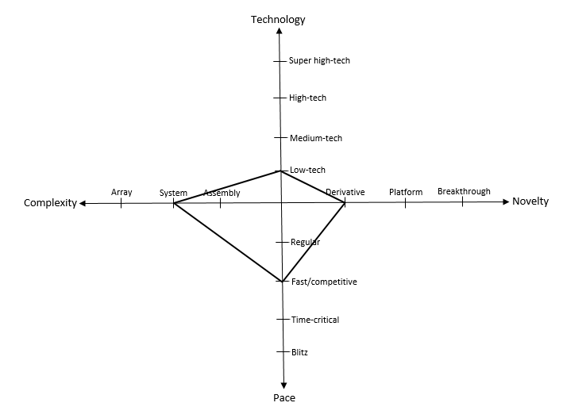

References
American Society of Landscape Architects. (2012). General Design: 2012 ASLA Professional Awards. Retrieved March 28, 2014, from American Society of Landscape Architects: http://www.asla.org/2012awards/512.html
Hagen, J. (n.d.). The Breaking of Michael Arad. Retrieved March 28, 2014, from New York Magazine: http://nymag.com/arts/architecture/features/17015/
Loos, T. (2011, September 1). Architect and 9/11 Memorial Both Evolved Over the Years. Retrieved March 28, 2014, from The New York Times: http://www.nytimes.com/2011/09/04/arts/design/how-the-911-memorial-changed-its-architect-michael-arad.html?pagewanted=all&_r=1&
Lower Manhattan Development Corporation. (n.d.). Renew NYC. Retrieved March 28, 2014, from Lower Manhattan Development Corporation: http://www.renewnyc.com/
Lower Manhattan Development Corporation. (n.d.). World Trade Center Site Memorial Competition: Official Competition Press Releases. Retrieved March 2, 2014, from World Trade Center Site Memorial: http://www.wtcsitememorial.org/pressreleases.html
National September 11 Memorial & Museum. (n.d.). About the Memorial. Retrieved March 2, 2014, from 9/11 Memorial: http://www.911memorial.org/about-memorial
National September 11 Memorial & Museum. (n.d.). Mission Statements. Retrieved March 2, 2014, from 9/11 Memorial: http://www.911memorial.org/mission-statements-0
The American Institute of Architects. (2013). National September 11 Memorial. Retrieved March 28, 2014, from The American Institute of Architects: http://www.aia.org/practicing/awards/2013/regional-urban-design/sept-11-memorial/index.htm
The National September 11 Memorial & Museum. (n.d.). The Visitors. Retrieved March 2, 2014, from The National September 11 Memorial & Museum: From Plaza to Bedrock: http://nsm-911memorial.cloudapp.net/
World Trade Center. (n.d.). WTC Timeline: Key Dates. Retrieved March 28, 2014, from World Trade Center: http://www.wtc.com/about/wtchistory-wtc-timeline

